# Trees

* Note: Abstract data type means is which use internally in-build data structure like, array or others. And tree is not use any in-build data structure.
* For build Tree, make one root node and for children trees call the recursion and then attached the all-children tree to root node.

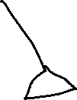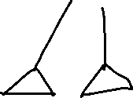

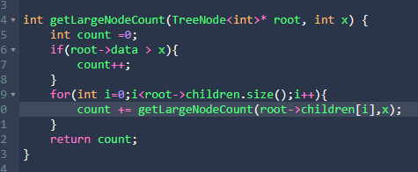

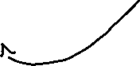

* dsd